**EMBOCS, Nawalaparsi**

**Class: 7(seven)**

**Grid for First Terminal Examination-2081**

**Subject: Health, Physical and Creative Arts Time: 2hrs FM: 50**

**PM: 18**

|  |  |  |  |  |  |
| --- | --- | --- | --- | --- | --- |
| SN | Chapters | Very short questions | Short questions | Long questions | Total Marks |
| 1 | Human Body | 3×1=3 | 3×2=6 | 1×4=4 | 13 |
| 2 | Community Health And Mental Health | 3×1=3 | 3×2=6 | 2×4=8 | 17 |
| 3 | Physical Training And Drill | 2×1=2 | 2×2=4 | 1×4=4 | 10 |
| 4 | Introduction To Arts, Drawing AndColour | 2×1=2 | 2×2=4 | 1×4=4 | 10 |
|  | Total | 10×1=10 | 10×2=20 | 5×4=20 | 50 |

**Model question for First Terminal Examination**

**Subject: Health, Physical and Creative Arts Time: 2hrs FM: 50**

**PM: 18**

**(Attempt all the following questions)**

**Group: A (Very short questions) 10×1=10**

1. Which blood cells fight against disease?
2. How many members are there in a heart ?
3. Which is the last track of digestive system ?
4. Who are called new born ?
5. Write one role of auxillary health worker of Nepal ?
6. Write some herbal medicine found in Nepal ?
7. Define drill ?
8. Write one importance of physical exercise ?
9. What is an art ?
10. Write the name of cool colour.

**Group: B (Short questions) 10×2=20**

1. Write the main function of Kidney.
2. Write one differences between Artery & Veins ?
3. Write the name of organs in digestive system ?
4. Define community health?
5. Write two short-term effects of using drugs.
6. Write two improtions of the immunizations .
7. How can we stay attention positions ?
8. Difine disper command in drill .
9. Draw some geometrical shape in drawing .
10. Why pencil is popular tool ?

**Group: C (Long questions) 5×4=20**

1. Draw a well-lebelled drigram of urinary system?
2. Make a list of the services provided by the auxillary health worker in Nepal ?
3. Explain about forward march and mark time .
4. What are the basic rules of art ?

**Class: 7(seven)**

**Grid for Second Terminal Examination-2081**

**Subject: Health, Physical and Creative Arts Time: 2hrs FM: 50**

**PM: 18**

|  |  |  |  |  |  |
| --- | --- | --- | --- | --- | --- |
| SN | Chapters | Very short questions | Short questions | Long questions | Total marks |
| 1 | Human Body | 1×1=1 | 2×2=4 | 1×4=4 | 9 |
| 2 | Community Health And Mental Health | 2×1=2 | 1×2=2 | 2×4=8 | 12 |
| 3 | Nutrition And Food Security | 1×1=1 | 2×2=4 | 1×4=4 | 9 |
| 4 | Physical Training And Drill | 1×1=1 | 1×2=2 |  | 3 |
| 5 | Athletics and adventure activities | 2×1=2 | 1×2=2 |  | 4 |
| 6 | Introduction To Arts, Drawing AndColour | 1×1=1 | 2×2=4 | 1×4=4 | 9 |
| 7 | Printing,Clay Work, collage and construction | 2×1=2 | 1×2=2 |  | 4 |
|  | Total | 10×1=10 | 10×2=20 | 5×4=20 | 50 |

**Model question for Second Terminal Examination**

**Subject: Health, Physical and Creative Arts Time: 2hrs FM: 50**

**PM: 18**

**(Attempt all the following questions)**

**Group: A (Very short questions) 10×1=10**

1. Which blood vessel carry oxygenated blood from the heart to different part of the body?
2. Write a function of health center .
3. Mention an importance of mental health.
4. Which vitamin strengthens our eyesight .
5. Difine dismiss command in drill.
6. Name any two sports played in water ?
7. What is athletics ?
8. Difine shape in drawing .
9. Write one use of clay?
10. Write the name of warm colours?

**Group: B (Short questions)**

1. **Difine** urinary bladder .
2. **What are the types of blood vessels ?**
3. Name some sources of protion.
4. Write two causes of using drugs .
5. Write down main effects of using junk food.
6. When is the eyes right command used?
7. What are the skills of high-jump ?
8. Mentions any three dimentions of art ?
9. Write any two properties of of clay?
10. Difine printmaking . **10×2=20**

**Group: C (Long questions) 5×4=20**

1. Describe blood –circulations peocess.
2. Write the role of auxillary nurse midwitery (ANM).
3. Write preventive measures of using drugs .
4. What are the haemful effects of food-adulterations .
5. Describe the types of colour.

**Class: 7(seven)**

**Grid for Third Terminal Examination-2081**

**Subject: Health, Physical and Creative Arts Time: 2hrs FM: 50**

**PM: 18**

|  |  |  |  |  |  |
| --- | --- | --- | --- | --- | --- |
| SN | Chapters | Very short questions | Short questions | Long questions | Total marks |
| 1 | Human Body | 1×1=1 |  | 1×4=4 | 5 |
| 2 | Community Health And Mental Health | 1×1=1 | 2×2=4 | 1×4=4 | 9 |
| 3 | Nutrition And Food Security | 1×1=1 | 2×2=4 |  | 5 |
| 4 | Disease, Safety Education And First Aid | 1×1=1 | 2×2=4 | 1×4=4 | 9 |
| 5 | Physical Training And Drill | 1×1=1 | 1×2=2 |  | 3 |
| 6 | Athletics and adventure activities | 1×1=1 | 1×2=2 |  | 3 |
| 7 | Games | 1×1=1 |  | 1×4=4 | 5 |
| 8 | Introduction To Arts, Drawing AndColour | 1×1=1 | 1×2=2 |  | 3 |
| 9 | Printing,Clay Work, collage and construction | 1×1=1 | 1×2=2 |  | 3 |
| 10 | Singing And Playing Instruments | 1×1=1 |  | 1×4=4 | 5 |
|  | Total | 10×1=10 | 10×2=20 | 5×4=20 | 50 |

**Model question for Third Terminal Examination**

**Subject: Health, Physical and Creative Arts Time: 2hrs FM: 50**

**PM: 18**

**(Attempt all the following questions)**

**Group: A (Very short questions) 10×1=10**

1. Write the one function of nose ?
2. What is diseases ?
3. What are drugs ?
4. Name some example of junk-foods.
5. How drill is done in a group.
6. Write some examples of althletics activities.
7. What are the basic skills of football ?
8. Define pencil.
9. How collage is done?
10. How many counts or taal in Kaharawa Taal.

**Group: B (Short questions) 10×2=20**

1. Define Mental -Health ?
2. What are the long-term effects of drug ?
3. Write two preventive-measures against food adultration ?
4. What are the functions of catbohydrates ?
5. Define first-aid.
6. What are the symptoms of tonsilits.
7. Why drum is used in drill ?
8. Why art is called an universal language ?
9. How can we play short-put .
10. What is coiling in clay work.

**Group: C (Long questions) 5×4=20**

1. Draw a well-lebeled diagram of human heart.
2. Why Yoga therapy is beneficial for human-body.
3. What are the first-aid for snake bite.
4. How kho-kho game is played ?
5. What is singing ? Write the importance of it .

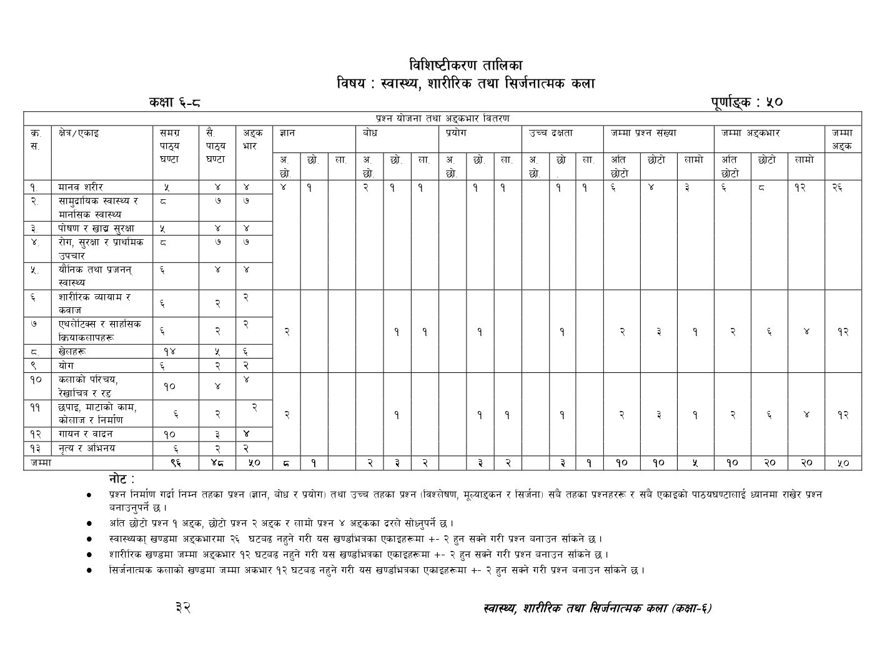

**Class: 7(seven)**

**Grid for Final Terminal Examination-2081**

**Subject: Health, Physical and Creative Arts Time: 2hrs FM: 50**

**PM: 18**

|  |  |  |  |  |  |  |
| --- | --- | --- | --- | --- | --- | --- |
| SN | Chapters | | Very short questions | Short questions | Long questions | Total marks |
| 1 | Human Body | | 2×1=2 | 1x2=2 |  | 4 |
| 2 | Community Health And Mental Health | | 1×1=1 | 1×2=2 | 1×4=4 | 7 |
| 3 | Nutrition And Food Security | | 2×1=2 | 1×2=2 |  | 4 |
| 4 | Disease, Safety Education And First Aid | | 1×1=1 | 1×2=2 | 1×4=4 | 7 |
| 5 | Sexual and reproductive Health | |  |  | 1x4=4 | 4 |
| 6 | Physical exercise and drill | |  | 1×2=2 |  | 2 |
| 7 | Athletics and adventure Activities | |  | 1x2=2 |  | 2 |
| 8 | Games | |  | 1×2=2 | 1x4=4 | 6 |
| 9 | Yoga | |  | 1×2=2 |  | 2 |
| 10 | Introduction to Arts, Line art and colour | |  |  | 1×4=4 | 4 |
| 11 | Printmaking, clay work, collage and construction | | 2x1=2 |  |  | 2 |
| 12 | | Singing and playing instrument | 2×1=2 | 1×2=2 |  | 4 |
| 13 | | Dance and acting | 2×1=2 |  |  | 2 |
|  | | Total | 10×1=10 | 10×2=20 | 5×4=20 | 50 |

**Question Construction Check List-1**

|  |  |  |  |  |  |  |  |
| --- | --- | --- | --- | --- | --- | --- | --- |
| **S.N.** | **Unit** | **Marks** | **K** | **U** | **A** | **HA** | **Total Marks** |
| **!** | **dfgj z/L/** | **$** | **1VS** | **1VS**  **1S** |  |  | **26** |
| **@** | **;fd'bflos :jf:Yo / dfgl;s :jf:Yo** | **&** | **1VS**  **1S** |  |  | **L** |
| **#** | **Kf]if0f vfB ;'/Iff** | **$** | **1VS** | **1VS** | **S** |  |
| **$** | **/f]u,;'/Iff / k|fylds pkrf/** | **&** |  | **L** | **L** |  |
| **%** | **of}lgs tyf k|hgg :jf:Yo** | **$** | **1VS** | **L** |  | **S** |
| **^** | **zf/Ll/s Jofod / sjfh** | **@** |  |  | **S** |  | **12** |
| **&** | **Pyn]l6S; / ;fxl;s lqmofsnfkx?** | **@** |  | **S** |  |  |
| **\*** | **v]nx?** | **^** | **2VS** | **L** |  |  |
| **(** | **of]u** | **@** |  |  |  | **S** |
| **!)** | **snfsf] kl/ro / /]vflrq /ª** | **$** |  |  | **L** |  | **12** |
| **!!** | **5kfO,df6fsf] sfd,sf]nfh / lgdf{0f** | **@** | **2VS** |  |  |  |
| **!@** | **ufog / jfbg** | **$** |  | **S** | **S** |  |
| **!#** | **g[To / clego** | **@** |  |  |  | **S** |  |
|  |  | **%)** | **10** | **16** | **14** | **10** | **50** |

**Model question for Final Terminal Examination**

**Subject: Health, Physical and Creative Arts Time: 2hrs FM: 50 PM: 18**

**(Attempt all the following questions)**

**Group: A (Very short questions) 10×1=10**

1. Define Blood.
2. Write the main function of Urinary system ?
3. Write the full-form of FCHV.
4. Write one long-term effect of Junk food ?
5. Define nutrient.
6. What is Lesbian.
7. How many players are there in Kabaddi ?
8. Which is the national game of Nepal ?
9. What are the different materials used in collage .
10. Draw a circular Gemetric Shape in drawing.

**Group: B (Short questions) 10×2=20**

1. Discribe about Heart in circulatory System.
2. Name some traditional health service system.
3. What are the ways to avoid junk food in school area.
4. Write the role of family in safer sexual behavior ?
5. “Drills develop discipline and social qualities “ Why ?
6. Define relay run.
7. What is yoga ?
8. Write Some Local- folk instruments found in Nepal .
9. What is Singing ?
10. Write two importance of drsmama and acting .
11. Make a list of material required for relief printing?

**Group: C (Long questions) 5×4=20**

1. What is a drug ? write down three reasons for consuming it .
2. Write first-aid methods for snake bites.
3. Write the symptoms of tuberculosis and its preventive measures.
4. What are the Skills used in Football. Describe the brief.
5. Define art. Draw any picture based in your imagination and colour it.